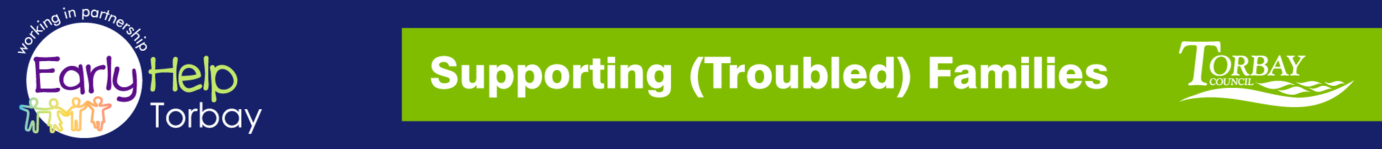

Supporting Families
NETWORK MEETING

TUESDAY 9th January 2018 9.30-12.00hrs
@ Paignton Library

A GENUINE NETWORKING OPPORTUNITY TO MEET AND SHARE YOUR EXPERIENCES WITH YOUR PARTNERS

AGENDA

- Minutes from last meeting
- Q&A Board - please email any questions to be discussed at this meeting
- Steve Leech - Update from Targeted Support
& Supporting Troubled Families
- Guest Speaker: Mandy Woodard Read Easy
- Refreshment Break
- Guest Speaker: Lorraine George – Early Years
- Guest Speaker: Tendai Chetse - Real Ideas
Organisation (RIO)
- Date, Venue & Time for next meeting

Reply to: nadia.cooper@torbay.gov.uk

steve.l eech@torbay.gov.uk your Interim Supporting (Troubled) Families Coordinator

