Request Reference: 17180922
Date received: 6 September 2017
Date response sent: 4 October 2017
1) Details of each Public Spaces Protection Order [PSPO] put forward for consultation by the local authority during the following time periods: 1 October 2014 to 30 September 2015; 1 October 2015 to 30 September 2016; 1 October 2016 to the most recent statistics for September 2017 (details should include the wording of the Order and a brief description of what was outlawed under the proposals);
1 October 2014 to 30 September 2015 | The Order prohibits and requires the following:  - No individual shall be permitted within the area edged red on the attached map to catch more than 20 mackerel within any 24 hour period. Any surplus mackerel must be returned to the sea immediately.  - At the request of an Authorised Officer, an individual must show all caught fish to that Officer for inspection (an Authorised Officer is an Officer of Torbay Council, Devon & Cornwall Police and/or Torbay Coast and Countryside Trust and their representatives).  - An individual shall immediately leave the area edged red on the attached map when directed to do so by an Authorised Officer and must not return to that area within 48 hours of that direction.  - No camping shall be permitted at any time within the area edged red on the attached map.  - No individual shall be permitted to erect a tent, shelter, bivouac or anything of a similar nature within the area edged red on the attached map.  - No individual shall drop, deposit or leave any form of litter or waste within the area edged red on the attached map.  - No individual shall be permitted to light a fire, barbeque or anything of a similar nature within the area edged red on the attached map.  - No individual shall be permitted to be associated with a fire, barbeque or anything of a similar nature within the area edged red on the attached map.  - No individual shall intimidate, obstruct or interfere with another individuals enjoyment of the area edged red on the attached map.  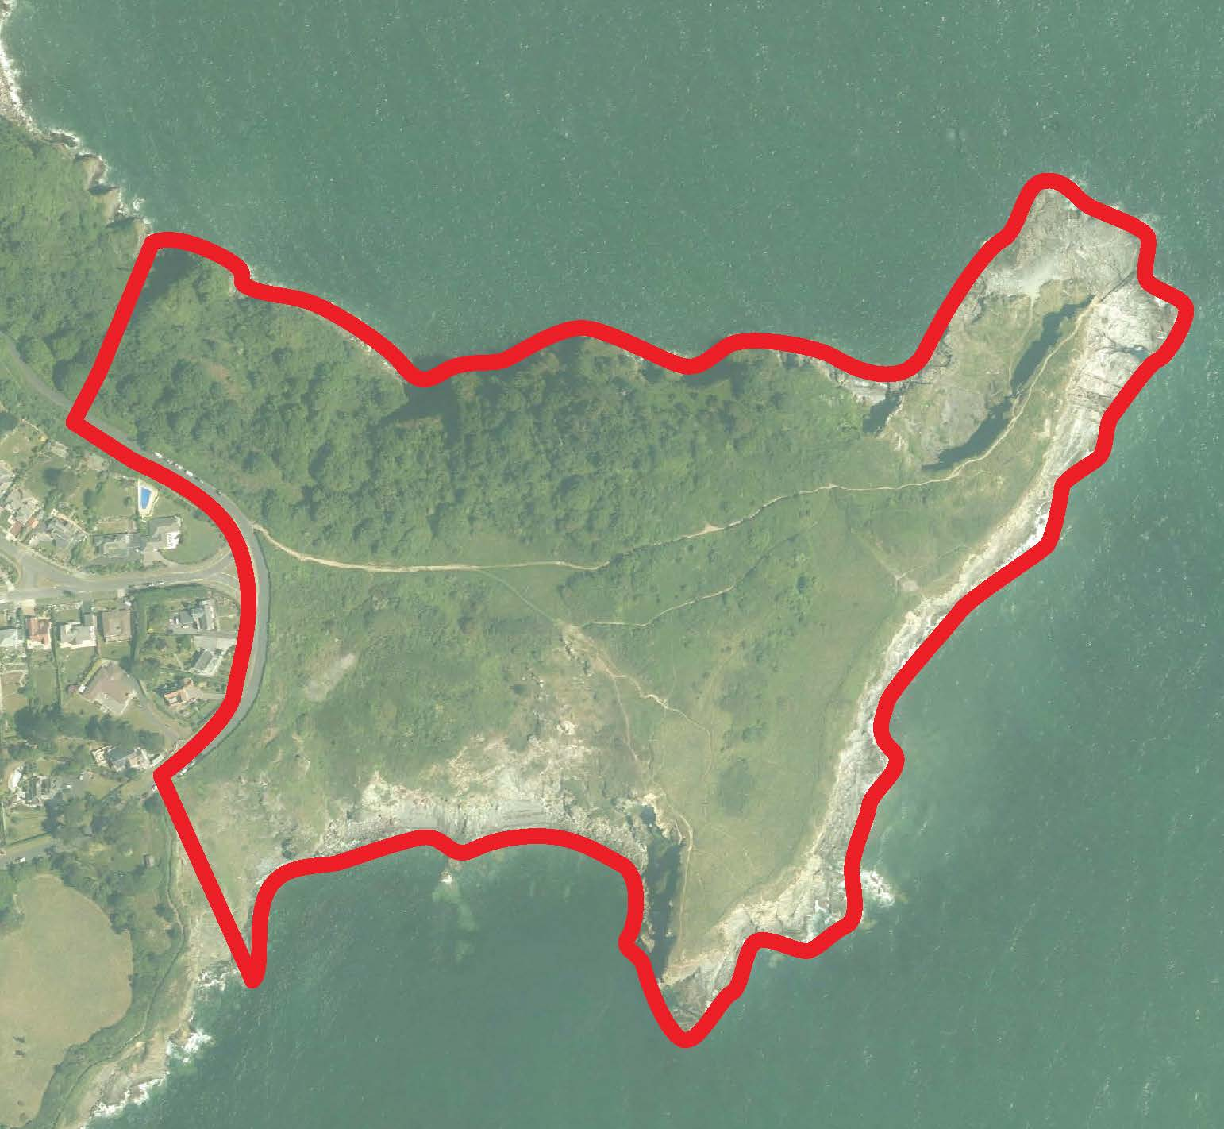
1 October 2015 to 30 September 2016 | N/A
1 October 2016 to the most recent statistics for September 2017 | N/A
2) Details of each Public Spaces Protection Order [PSPO] introduced by the local authority for the following time periods: 1 October 2014 to 30 September 2015; 1 October 2015 to 30 September 2016; 1 October 2016 to the most recent statistics for September 2017 (details should include the wording of the Order and a brief description of each act outlawed under the order);
1 October 2014 to 30 September 2015 | n/a
1 October 2015 to 30 September 2016 | As above – see www.torbay.gov.uk/hopesnose
1 October 2016 to the most recent statistics for September 2017 | n/a
3) The number of fixed penalty notices issued for breach of a PSPO for the following time periods: 1 October 2014 to 30 September 2015; 1 October 2015 to 30 September 2016; 1 October 2016 to September 2017 or the most recent statistics available;
1 October 2014 to 30 September 2015 | n/a
1 October 2015 to 30 September 2016 | 0
1 October 2016 to the most recent statistics for September 2017 | 0
4) The initial ‘fine’ amount for a fixed penalty notice issued for breach of a PSPO.
1 October 2014 to 30 September 2015 | N/A
1 October 2015 to 30 September 2016 | 80
1 October 2016 to the most recent statistics for September 2017 | 80

