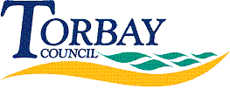
Request Reference: 1718188
Date received: 5 May 2017
Date response sent: 7 June 2017

1. Please can you tell me how much funding your 'health protection' budget (part of the Public Health budget) has received for 2017/18.

£84,000

2. Please also tell me how much funding the health protection budget received in 2013/14, 2014/15, 2015/16 and 2016/17.

2013/14 | £26,000
2014/15 | £71,700
2015/16 | £84,000
2016/17 | £84,000

