**Request Reference: 17180333**

**Date received: 1 June 2017**

**Date response sent: 13 July 2017**

**I would like to request the following information:**

**1) Amount spent on parking services in the last financial year**

Under Section 22 of the Freedom of Information Act 2000, the Council is not required to provide information in response to a request where the requested information is intended for future publication.

The information requested will be available on the council website when the accounts have been finalised.

<http://www.torbay.gov.uk/council/policies/parking-policies/>

This is an absolute exemption and therefore there is no requirement to consider the Public Interest Test.

**2) Amount raised**

Under Section 22 of the Freedom of Information Act 2000, the Council is not required to provide information in response to a request where the requested information is intended for future publication.

The information requested will be available on the council website when the accounts have been finalised.

<http://www.torbay.gov.uk/council/policies/parking-policies/>

This is an absolute exemption and therefore there is no requirement to consider the Public Interest Test.

**3) Number of PCN notices issued**

28141

**4) Number of appeals**

The number of appeals are registered with Traffic penalty Tribunal and they will be able to provide this information. There may be an annual report on the website at <https://www.trafficpenaltytribunal.gov.uk/>

**5) Number of appeals allowed**

Please see 4 above

**6) Any performance data relating to the number of parking machine failures**

This information is electronic and the machine reports when there are failures via the system.

**7) Number of appeals relating to machine failures**

Please see 4 above – but the decision will not be logged for the exact reason

**8) Number allowed**

Please see 4 above

**9) Number of times (and minutes) when councillors considered the performance of parking services in Torbay**

The Audit Committee receives quarterly reporting on the Councils key performance indicators reports and minutes for the audit committee can be found on the following link;

<http://www.torbay.gov.uk/DemocraticServices/ieListMeetings.aspx?CId=124&Year=0>

**10) Any audit data or reports providing assurance that the system is operating in accordance with the law and the intentions of the council.**

Last audit on Parking Services was undertaken in 2013/14;

The scope of the 2013/14 audit was limited to the following (extract below from the actual audit report, which as noted in point 3 below is not a public document):

The audit for 2013/14 has been undertaken on the following key risks, identified based on discussions with the department and Internal Audit's view on risk within the function. The key risks are:

Inappropriate or inaccurate amendments made to the Civica Enforcement system

Loss of parking permits or income.

The following risk area was not assessed in 2013/14 due to the time allocated for this audit.

Regulatory requirements, performance targets and best practice expectations not met.

However, Risks 2 and 3 testing areas detailed within the report refer to written procedures and in this respect testing has therefore been undertaken in respect of procedures and working practices relating to Parking Services functions tested within this audit i.e. the issuing of parking permits (including staff permits) and scratch cards, the issuing of Penalty Charge Notices and cancellation / recovery action.

Our performance report for 2013/14 outturn which went to Audit Committee is a public document, and contains basic information about the Parking Services Audit (extract provided at Fig.1 below and full report attached for information if required);

As you can see from Fig.1 the area was given Improvements Required and would therefore be subject to our annual follow up process. Again, this is reported in a follow up outturn report (extract provided at Fig.2 below). Our opinion remained as Improvements required however our Exec summary was revised to reflect some progress made

**11) Any data relating to citizen satisfaction with parking in Torbay.**

Parking Review held a consultation and the surveys were undertaken. The findings of these were considered. Please see <http://www.torbay.gov.uk/council/policies/parking-policies/> for more information.

Fig.1

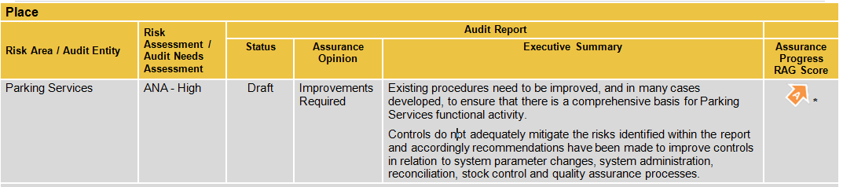

As you can see from Fig.1 the area was given Improvements Required and would therefore be subject to our annual follow up process. Again, this is reported in a follow up outturn report (extract provided at Fig.2 below). Our opinion remained as Improvements required however our Exec summary was revised to reflect some progress made.

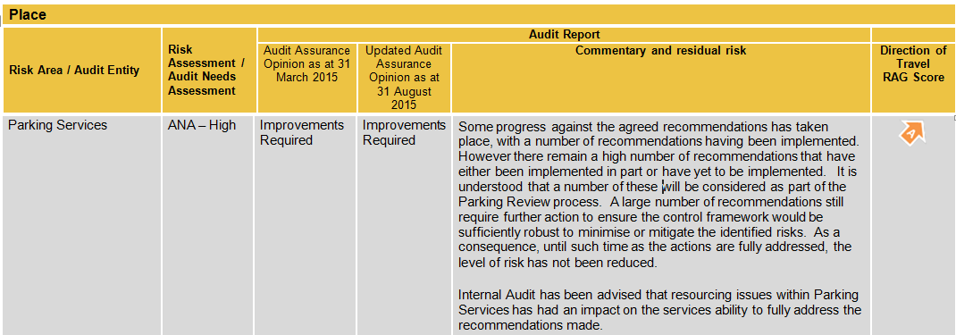Fig.2