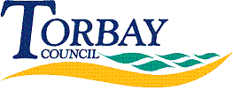
Request Reference: 17180338
Date received: 5 June 2017
Date response sent: 3 July 2017

Please could you provide me with the following information about each private company owned, or part owned, by Torbay Council for the dates 2011-present (including companies that have been terminated within those dates):

1. Name of company
2. Percentage owned by the council
3. Main objective or objectives of the company
Under Section 21 of the Freedom of Information Act 2000, the Council is not required to respond to a request where the information being requested is already accessible.
This information can be found from page 77 within the Statement of Accounts available on our website at http://www.torbay.gov.uk/council/finance/statement-of-accounts/

